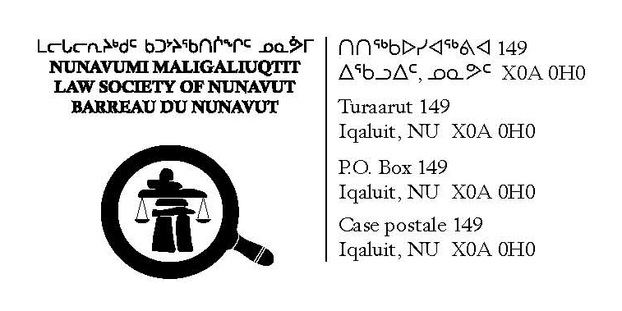  Change of Status  Inactive to Active or Reinstatement
  Tel: 867-979-2330
  Fax: 867-979-2333
  Email: administrator@lawsociety.nu.ca
  Website: www.lawsociety.nu.ca
Law Society of Nunavut Membership

FORM R
(Paragraph 53(2)(a) and 59.1(1)(a))

APPLICATION FOR CHANGE OF STATUS TO AN ACTIVE MEMBER
or for REINSTATEMENT OF A MEMBER WHO RESIGNED

TO: The Secretary
Law Society of Nunavut

I, ___________________________________ , of ___________________________________ , hereby apply
(full name)

_____ to change my status from an inactive member to an active member of the Law Society of Nunavut.

OR

_____ for reinstatement as an active member of the Law Society of Nunavut after having resigned.

1. The address to which correspondence is to be sent to me is ______________________________________ ____________________________________________________________________________________________________________________________________________________________________________________________________________________________________________________________________________________

Telephone Number: (_____) _____________________ Fax Number: (_____) _____________________

2. I have been an inactive member since _________________________________.

OR

I resigned as a member on _________________________________.

3. As an active member, I will be practicing law with the following firm or employer under the firm name of :

_____________________________________________________________________________________
(name of firm or employer)

_____________________________________________________________________________________ _____________________________________________________________________________________ _____________________________________________________________________________________
(business address of firm or employer)

4. I will be principally practicing law in _____________________________________________________ .
(name of jurisdiction)

- (1) I am or have been a member of the following law societies, or comparable bodies, for the following periods of time:
__________________________________________________________________________________
__________________________________________________________________________________

(2) Since the later of my Application for Admission (Form D) or my last Application for Renewal (Form T), I have been actively engaging in practicing law in the following jurisdictions for the following periods of time:
___________________________________________________________________________________
___________________________________________________________________________________

(3) Since the later of my Form D or last Form T, no disciplinary proceedings are pending or have been taken against me as a member of the societies or bodies listed in subsection (1) except:
_____________________________________________________________________________________
_____________________________________________________________________________________

(4) The results of any disciplinary proceedings taken against me were:
_____________________________________________________________________________________
_____________________________________________________________________________________

(5) Since the later of my Form D or last Form T, no claims for lawyer’s professional liability insurance are pending or have been made against me as a member of the societies or bodies listed in subsection (1) except:
_____________________________________________________________________________________
_____________________________________________________________________________________

(6) The results of any claims for lawyer’s professional liability insurance listed in subsection (5) were:
_____________________________________________________________________________________
_____________________________________________________________________________________

- Annexed to this application are:
  - a certificate from each provincial or territorial law society or comparable body of which I am a member stating:
    - that I am in good standing;
    - the period of time which I have been listed as an active member of the society or body;
    - whether disciplinary proceedings are pending against me;
    - the nature and disposition of any disciplinary action that has been taken against me;
  - an Accountant’s Report in Form E or my Statutory Declaration in Form F or a statement indicating that I am joining a partnership that, or am becoming associated with a member who, has filed a Certificate of Accountant and Member in Form V;
  - the Insurance levy or my insurance Exemption Certificate and Undertaking;
  - the assurance fund levy; and
  - the prescribed fees for a change of status to an active member or reinstatement of a member who resigned, as applicable.

- I certify that the information I have provided in or annexed to this application is correct.

Dated at _____________________________________ on _____________________________________ .
(place) (date)

__________________________________________
(signature of applicant)

