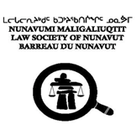

Assurance and Authorization Form

I,      , have reviewed the information provided in the attached Certificate of Standing which was prepared at my request by the Law Society of Nunavut as a pre-condition to my application for:

1. call and admission on transfer; or
2. an occasional appearance in your jurisdiction.

I acknowledge that the information contained in the Certificate is accurate and complete, and I authorize the release of this information to your Society. I authorize your Society to make enquiries concerning my background, character and fitness for admission to your Society, that I also authorize the disclosure of information about myself to your Society by any person or body possessing it, provided that such information will be used by your Society only for the purpose of this application, and will be treated in strict confidence.

_________________________________

Signature of Applicant

Date: Click here to enter a date.